Lesson 2 Demo 5: Working with Docker Commands

This section will guide you to:

* Use Docker commands instead of kubectl commands in a static pod

This lab has one sub-section, namely:

1. Using Docker commands in a static pod

**Note:** If you don’t have an existing Kubernetes cluster, refer to the Demo 1.1 of Lesson 1.

**Step 1:** Using Docker commands in a static pod

**Note:** You can use the kubectl commands to interact with the API Server. Using kubectl is straightforward if you are familiar with the docker command line tool. However, there are a few differences between the docker commands and the kubectl commands.

* Use the *docker run* command to run an nginx deployment and expose the deployment on port 80

*sudo docker run -d --restart=always *

*-e DOMAIN=cluster --name nginx-app -p 80:80 nginx*

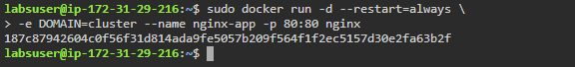

**Note**: We had already started an nginx container in our previous demos. In case you get an error while executing the above command, run the following commands and then execute the last step.

*sudo docker ps -a*   
(Check the container id of the ngnix container and copy it)

*sudo docker stop <containerId>*

*sudo docker rm <containerId>*

* List the currently running containers

*sudo docker ps -a*

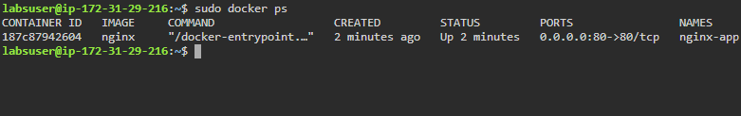

* Attach a process that is already running in a container

*sudo docker attach <containerId>*

***Note:*** *Replace containerId with the ID of the container you wish to attach*



* Execute a command inside a running container

*sudo docker exec <containerId> cat /etc/hostname*

***Note:*** *Replace containerId with the ID of the container*



* Check the logs of a running container to see the **stdout/stderr**

*sudo docker logs -f <container id>*

***Note:*** *Replace containerId with the ID of the container*

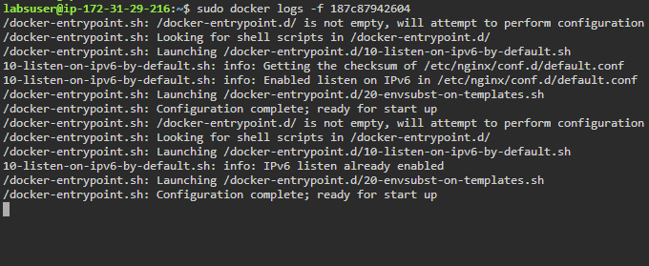

* Stop a running container

*sudo docker stop <container id>*

***Note:*** *Replace containerId with the ID of the container*

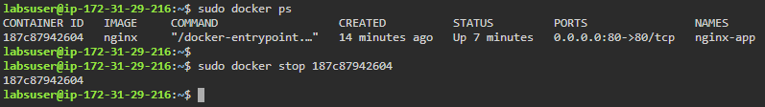

* Delete a running container

*sudo docker rm <container id>*

***Note:*** *Replace containerId with the ID of the container*



* Get the version of Docker Client and Server

*sudo docker version*

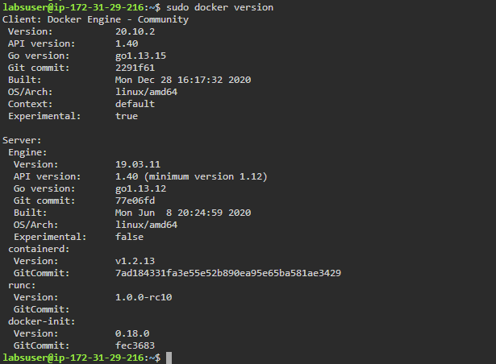

* Get the miscellaneous information about the Docker environment and configuration

*sudo docker info*

